**Creating Identity and Access Management (IAM) Users**

* Under your account name in the top-left corner of the console select **“Security Credentials”**

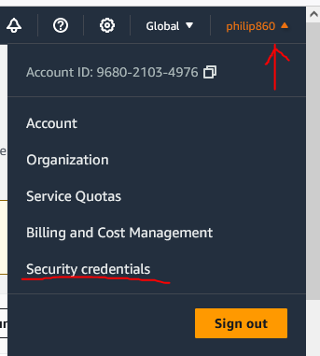

* In the newly opened window, there will be an option for “Users” in the Identity and Access Management toolbar.

* Enter any username you desire….and don’t select “Provide user…” checkbox, then hit next.

* We need to add this user to a desired group, if this is a first-time setup for your aws account, you need to select the **“Create Group”** option.

* Enter a desired group name, and to grant full admin access for this group check the first checkbox in the window…

* Now check the checkbox on the newly create group and select next

* Now click “**Create User**”…

**Creating Identity and Access Management (IAM) Access Key**

* In the IAM users window, click on the specific user you wish to create the access key for

* Now click on the **“Create Access Key”** link.

* Now specify a use case for the access key, and select next

* Now specify a description for the new key, and select **“Create Access Key”**

